**spark shell:**

Spark-shell command starts the spark

Create rdd using parallelize:

Read:textfile reads the file into the given rdd.



Take:to read first 3 lines

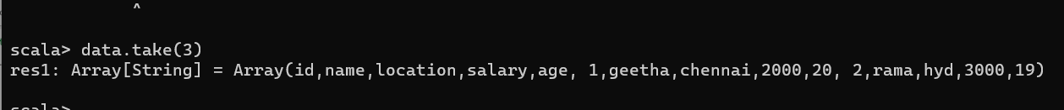

Count:

Filter:

First:

Distinct:

Union:

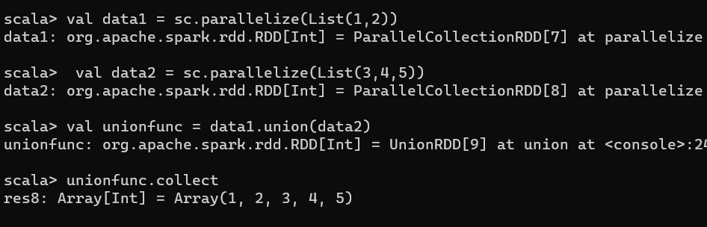

Sort:

Quit command:

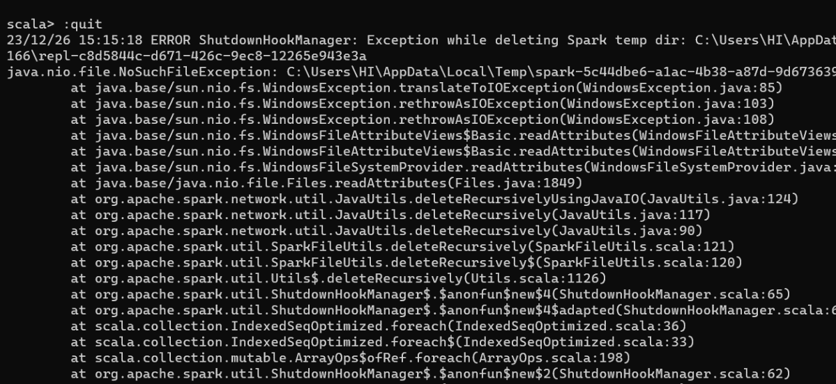

**Pyspark:**

Type pyspark command in cmd to start pyspark:

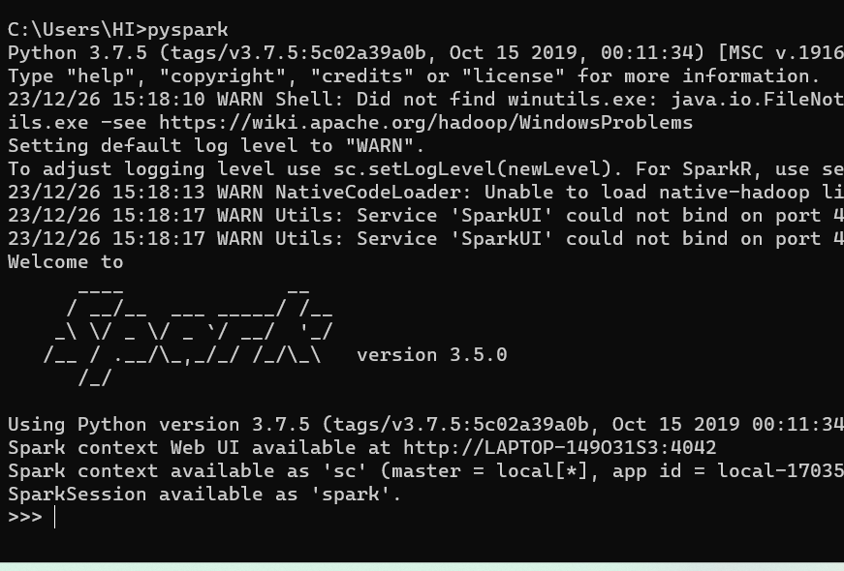

Reading files:

Spark.read.load(): This function is utilized to load a file into the Spark shell, making the data accessible for further processing.

printSchema:

gives the schema of the dataframe:

Topandas:

Is used to change the dataframe to pandas data frame:

Limit is used to limit the values upto specified number.

Sort:

Filter:

Sql:

* **Var_name.registerTempTable('table_name'):** This command registers a DataFrame as a temporary table, facilitating SQL-like operations for enhanced performance.
* **sqlContext.sql('query'):** The sqlContext.sql() function is used to execute SQL queries on the registered temporary tables within PySpark.

**Df.**registerTempTable(‘name’)

